The Vigenere Algorithm Project

Jeffrey Clarke Jackson

5/25/2005

Dr. Ahmed Desoky – Introduction to Cryptology

Introduction – Program Instructions

An introduction on how to use the program would probably be appropriate. There are 3 ways to use the program: encryption, decryption, and attack. Let’s first begin with the case where we know the cipher text and the key for decryption. On the upper portion of the form contains a text box labeled cipher text, and to the right a text line for key entry.

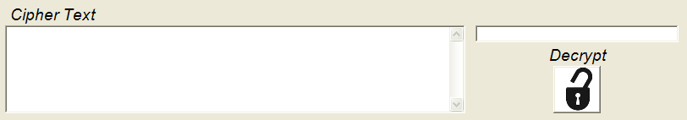
Decryption Section

To insert cipher text into this text box, simply use the File option at the top of the application and click the “Open CipherText” command. Navigate to the cipher text that you would like to load and open it. During the open command a routine will remove the carriage return, line feeds, spaces, and then lowercase all the characters. The actual programming behind these methods will be discussed later. Once your cipher text has been loaded, you can enter the key and decrypt with the button below. Your decrypted message will display in the plain text area on the bottom of your screen.
In the case that you have a plain text message you would like to encrypt, use the File option as before but click “Open PlainText”. Alternatively you can type your plain text message lowercased into the text box itself without spaces, or any other various escape characters. Just like the decryption method, put the key that you would like to use into the box on the right and press encrypt. The save dialog box will ask you where you would like to save your encrypted file.

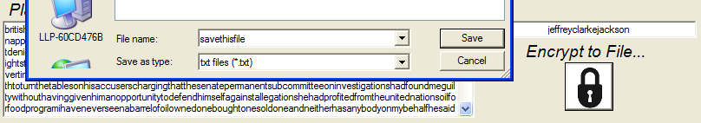
Encryption Section

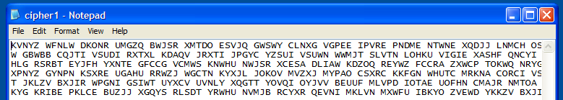
Generated Cipher Text
To attack a cipher text, load the file like you normally would for decryption. When a cipher text is loaded it is automatically checked with the Index of Coincidences algorithm. The list box to your left fills out and you can specify what key length you would like to perform your analysis with. Simply pick an index of coincidence that is higher than the others and three analysis methods will attempt to calculate the probable key. To the right of the list box will be the results from the three methods of attack. The methods used are Dot Product, Sum of Absolute Differences, and the Sum of Squares. Similar to the regular decryption, each probable key will have its own button to initiate the decryption. This way if you have varying results you can test with each key. In some cases, each method will produce a slightly different key depending on the cipher text and key lengths.

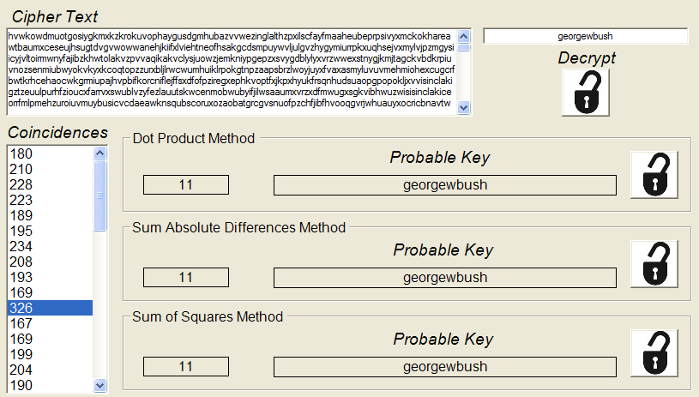
Analysis/Attack Section
Development - Source Code

The attack and analysis for the Vigenere algorithm was straight forward. First when a cipher text file is read in, it is preprocessed to remove all unwanted characters and formatting. After this an algorithm to determine the index of coincidences will be executed. By default, the program will calculate up to 50 indexes.
Once the indexes have been calculated, the list box will generate an event when clicked to begin calculating the probable keys based on the three methods. Depending on the key length, W Tables will be calculated based on the distribution of shifted cipher text. These W Tables are then used against A Vectors that contain the English letter frequency distribution to calculate the probable key. The various A vectors are stored statically. This way less shifting would have to be done by the processor, and a simple procedure call is only needed to return the necessary A vector. The parameter for this function is the number of desired shifts.
C# has a very nice built in API library. For example, when parsing out the escape characters, and changing text from uppercase to lowercase and vice versa, all that was needed was some string class methods. ToString(), ToUpper(), ToLower(), Replace() are string methods that allowed parsing to be very straightforward. When performing calculations, the cipher text was broken down into a character array with a simple .ToCharArray(). Even though the API is quite similar to Java, the functionality and dependability is not quite as good. When attempting to write the cipher text file to disk, there were problems when streaming the file as a string object. For instance, the data would be corrupted at the very beginning with unwanted symbols. When the same string was converted to a character array prior to streaming, the file was then generated correctly.
During development it was noted that some programming improvements could have been made. Even though the current algorithm produces the intended results, the dot product method could have been altered to only compute against the necessary elements and not every possible one. Since i-j and j-i give the same dot products, the program only needs to compute the up to the absolute value of i-j.
Another consideration was the use of threads. Threads would have been useful while performing each method simultaneously. Due to the simplicity of the project it was decided that this was not totally necessary. However, as later projects are assigned it might be necessary to use threads if algorithms need the extra simultaneous computing capability.

Analysis – Cipher Text Attack

After generating 3 cipher texts files to use for analysis, all of them were easily resolved using the attack system in the program. In one case the key didn’t calculate right for one of the methods, this is due to the fact the key length was proportional larger than other keys when compared to the cipher text itself. For a good attack it is necessary to have enough characters in the cipher text files to create a good distribution when shifting. This way calculating the period will have less error, as well as the various summations and products of the 3 attack methods.
It should also be noted that the plain text itself is assumed to have a normal distribution of English letter frequencies. Since the program is hard coded with this information, it will most likely not work for cipher texts that are encrypted for other languages. Three extra cipher texts have been generated which contain the same message however translated into 3 different languages: English, French, & German.
After analyzing the results each were easily solved with all three methods. It would seem that the distributions of the letters are close enough to each other so that the English frequency works interchangeable with other languages. This would be assumed up to a certain level since some languages contain characters that other languages do not. In the case of Arabic, or Chinese the frequency table is expected to obviously be much different.

Conclusion

Based on theory and actual practices in the program, algorithms such as these should be quite effective for cryptographic schemes where the keys are symmetric, and the encryption is based on linear shifting. Some languages tend to have a similar distribution of letters, so some frequency vectors could possibly work for more than just the intended language. In conclusion, the Vigenere Algorithm Project was interesting to develop since it incorporated vector mathematics, and the use of a relatively new programming language. Listed below are the keys to the provided cipher texts files.

vig.txt – georgewbush
ciphertext1.txt – email
ciphertext2.txt – johannnepomukhummel
ciphertext3.txt – french
ciphertext4.txt – german
ciphertext5.txt - english

